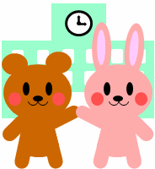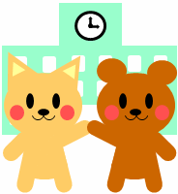

時間割表

|  |  |  |  |  |  |  |
| --- | --- | --- | --- | --- | --- | --- |
|  | 月 | 火 | 水 | 木 | 金 | 土 |
| １ |  |  |  |  |  |  |
| ２ |  |  |  |  |  |  |
| ３ |  |  |  |  |  |  |
| ４ |  |  |  |  |  |  |
| ５ |  |  |  |  |  |  |
| ６ |  |  |  |  |  |  |
| 7 |  |  |  |  |  |  |